**CASE STUDY: Amazon Top 50 Bestselling Books 2009 - 2019**

**OVERVIEW:-**

The objective of this analysis is to look at the top 50 bestselling books on Amazon. The data we set contains the book name it’s author, the price and the year of publication along with it’s reviews and rating.

**LIMITATIONS:-**

The data set had only the name,author,price, year, reviews and its rating, the data set does not contain the number of books sold or any such info regarding it.

**ANALYSIS:-**

Throughout the preparation and analysis of our data set, we will be focusing on 3 questions:

1. Which book has the highest rating
2. Which book has the highest reviews
3. Which author have written the most bestselling books

With the abovementioned questions in mind, we will be focusing on the data set named Amazon Top 50 Bestselling Books 2009 - 2019.

THE BOOKS HAVING THE HIGHEST RATING;

We will be considering books which have ratings above 4.7 as 4.8 is the most recurring rating.

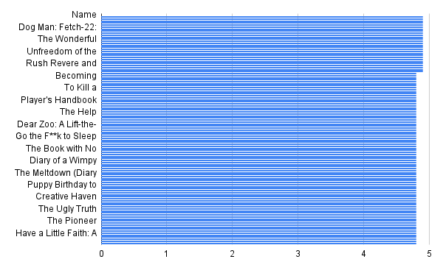

The top 50 books with the highest reviews:

This graph shows the highest rated and the books which has the highest rating in the site.

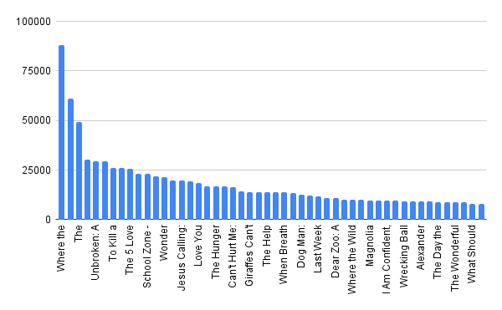

THE AUTHOR’S WHO WROTE THE MOST BESTSELLERS:

|  |  |  |
| --- | --- | --- |
|  | Author | Count |
| 5 | Dr. Seuss | 8 |
| 4 | Dav Pilkey | 7 |
| 7 | Eric Carle | 7 |
| 18 | Sarah Young | 6 |
| 6 | Emily Winfield Martin | 4 |
| 9 | J.K. Rowling | 3 |
| 19 | Sherri Duskey Rinker | 2 |
| 17 | Rush Limbaugh | 2 |
| 1 | Bill Martin Jr. | 2 |

## **The Percentage of fictional and non-fictional books**

## 

## 

## **Conclusion:-**

We can find that the number of fictional books are more than non-fictional books. Along with it the non-fictional books are more expensive than fictional books. The authors who wrote more bestselling books are fictional books.